Tyson Martin

COM-391

Prof. Estey

Activity 0

03/09/2025

**Tools Installation and Initial Applications**

Screenshots:

node -v & npm -v

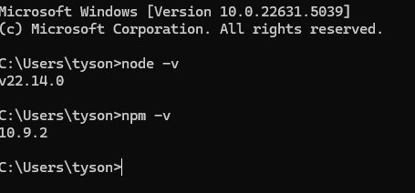

Hello world console app:

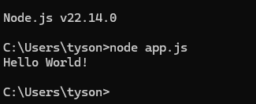

Hello world web app:



Changed Message:

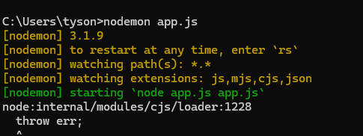

Hello world from TS:



TS in vs code with comments:

